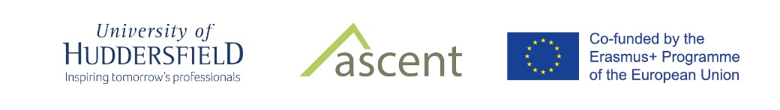
ASCENT project consortium
Programme Countries (Europe);
University of Huddersfield, United Kingdom (Lead Partner)
University of Central Lancashire, United Kingdom
Lund University, Sweden
Mid-Sweden University, Sweden
Vilnius Gediminas Technical University, Lithuania
Tallinn University of Technology, Estonia
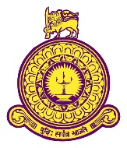
ASCENT Team, University of Colombo, Sri Lanka
Manager- Dr. Nishara Fernando (nishara.fernando@gmail.com)
Researcher- Prof. Siri Hettige (hettigesiri@gmail.com )
Admin Assistant – Udari Samarakoon (udasuba123@gmail.com)
Technical Assistant- Malith De Silva (malithsilva10@gmail.com)

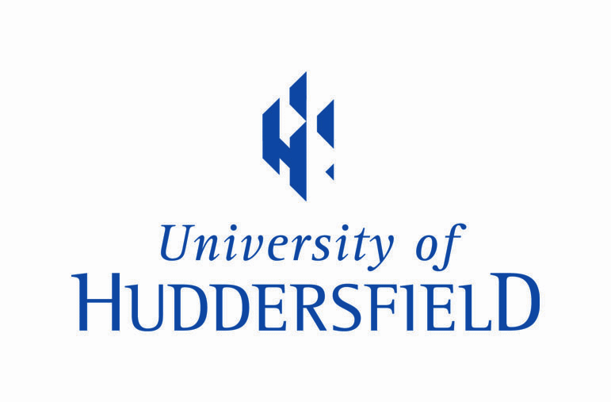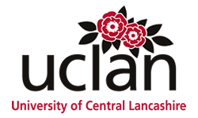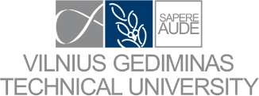
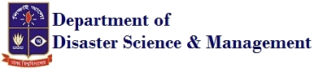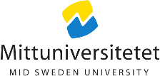

Partner Countries (Asia)
University of Moratuwa, Sri Lanka
University of Colombo, Sri Lanka
University of Ruhuna, Sri Lanka
University of Naresuan, Thailand
Chiang Mai University, Thailand
University of Dhaka, Bangladesh
BRAC University, Bangladesh
Patuakhali Science and Technology University

